Macintosh:Users:Katy:Desktop:Picture 1.pngMacintosh:Users:Katy:Desktop:Picture 2.pngMacintosh:Users:Katy:Desktop:Picture 4.pngMacintosh:Users:Katy:Desktop:Picture 5.pngMacintosh:Users:Katy:Desktop:Picture 7.pngMacintosh:Users:Katy:Desktop:Picture 9.png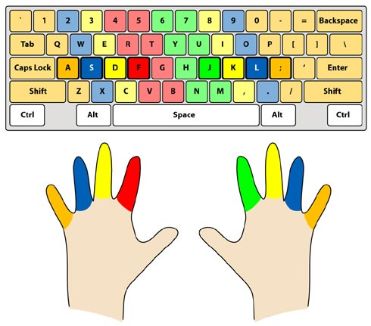

Macintosh:Users:Katy:Desktop:Picture 1.pngMacintosh:Users:Katy:Desktop:Picture 2.pngMacintosh:Users:Katy:Desktop:Picture 4.pngMacintosh:Users:Katy:Desktop:Picture 5.pngMacintosh:Users:Katy:Desktop:Picture 7.pngMacintosh:Users:Katy:Desktop:Picture 9.png

